# Anteater Groups: Goal-Oriented Analysis Model

# Model 1: “Enhance Students’ Interests”

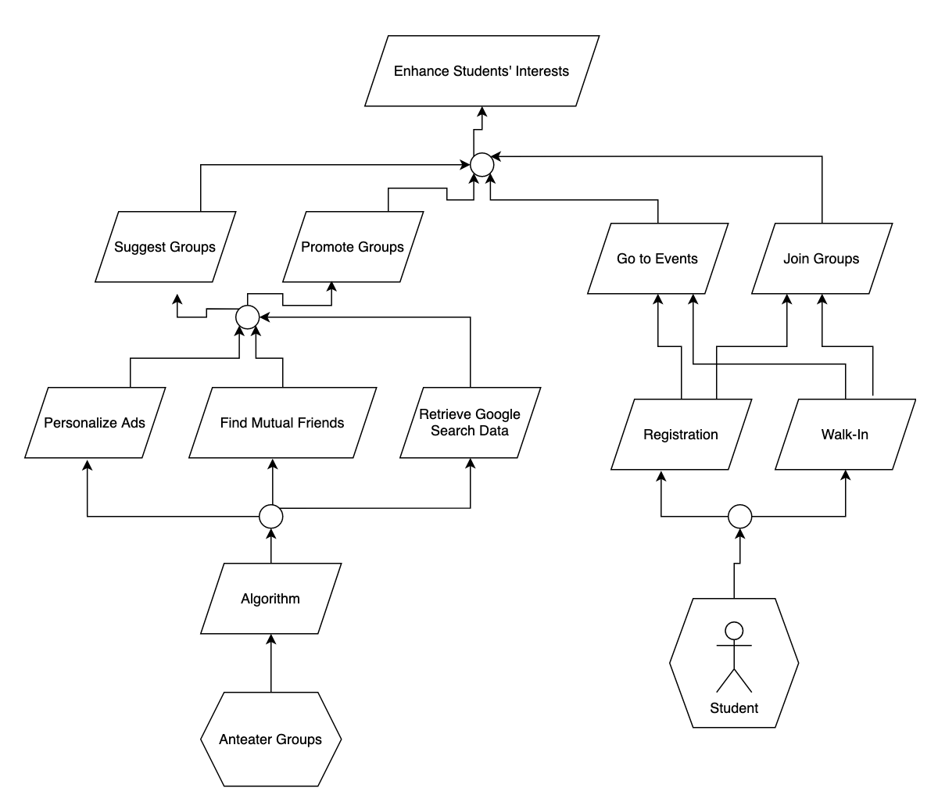

Goal priorities are categorized as Low, Medium, High.

Source numbers refer to the numbered list in the Field Notes section from elicitation sessions.

1. **Enhance students’ interests**
   1. Definition: Anteater Groups shall enhance student’s current interests through using the app.
   2. Type: Soft
   3. Source: Case Study
   4. Priority: High
2. **Suggest Groups**
   1. Definition: Students shall see suggestions for groups on a floating banner or a pop-up as personalized ads based on their online searches and browsing history on the app.
   2. Type: Achieve
   3. Source: 22, 27, 67
   4. Priority: Medium
3. **Promote Groups**
   1. Definition: Students shall see promotion based on their interests and connections with other students based on their mutual friend list.
   2. Type: Achieve
   3. Source: 22, 27, 67
   4. Priority: High
4. **Join Groups**
   1. Definition: Students shall be able to register to join groups.
   2. Type: Achieve
   3. Source: 6
   4. Priority: High
5. **Go to Events**
   1. Definition: Students shall be able to go directly to events as walk-in.
   2. Type: Achieve
   3. Source: 6
   4. Priority: Medium
6. **Personalize Ads**
   1. Definition: Students shall see personalized ads to join groups based on their interests.
   2. Type: Achieve
   3. Source: 67
   4. Priority: High
7. **Find Mutual Friends**
   1. Definition: Students shall see mutual friends and for connections through friend requests.
   2. Type: Achieve
   3. Source: 27, 70
   4. Priority: High
8. **Retrieve Google Search Data**
   1. Definition: Students shall see suggested groups based on their browsing history from Google.
   2. Type: Achieve
   3. Source: 67
   4. Priority: Medium
9. **Registration** 
   1. Definition: Students shall be able to register to join groups.
   2. Type: Achieve
   3. Source: 45
   4. Priority: High
10. **Walk-in**
    1. Definition: Students shall have the option to join groups as walk-in.
    2. Type: Achieve
    3. Source: 45
    4. Priority: Medium
11. **Algorithm**
    1. Definition: System shall use machine learning algorithms to implement personalized recommendations.
    2. Type: Maintain
    3. Source: 25, 67
    4. Priority: High

# Model 2: “Improve students’ social connectedness”

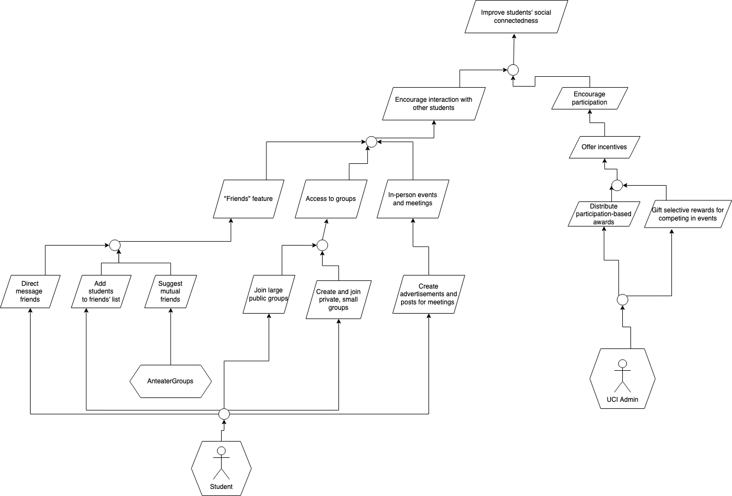

Goal priorities are categorized as Low, Medium, High.

Source numbers refer to the numbered list in the Field Notes section from elicitation sessions.

1. **Improve students’ social connectedness**
   1. Definition: Anteater Groups shall improve students’ social connectedness through their use of the app.
   2. Type: Soft
   3. Source: Case Study
   4. Priority: High
2. **Encourage interaction with other students**
   1. Definition: The system should promote communication between UCI students.
   2. Type: Soft
   3. Source: 2, 5, 6, 11, 19, 27, 30
   4. Priority: High
3. **Encourage participation**
   1. Definition: The system should promote students’ participation in events.
   2. Type: Soft
   3. Source: 7, 9, 42
   4. Priority: High
4. **Offer incentives**
   1. Definition: UCI Administration shall offer incentives to students to encourage them to participate in activities.
   2. Type: Achieve
   3. Source: 7, 9, 42
   4. Priority: High
5. **“Friends” feature**
   1. Definition: AnteaterGroups shall give students the ability to have a list of friends.
   2. Type: Maintain
   3. Source: 49
   4. Priority: High
6. **Access to groups**
   1. Definition: Students shall have access to large public groups and smaller private groups.
   2. Type: Maintain
   3. Source: 63, 64
   4. Priority: High
7. **Establish in-person events and meetings**
   1. Definition: Students shall be able to attend events and meetings in-person on campus.
   2. Type: Achieve
   3. Source: 46, 47
   4. Priority: High
8. **Distribute participation-based rewards**
   1. Definition: Students shall receive rewards for participating in events.
   2. Type: Achieve
   3. Source: 9, 42
   4. Priority: High
9. **Gift selective rewards for competing in events**
   1. Definition: Administration shall gift select students rewards for winning raffles or in-person events.
   2. Type: Achieve
   3. Source: 7, 9, 42
   4. Priority: Medium
10. **Direct message friends**
    1. Definition: Students shall always be able to direct messaging those on their friends list.
    2. Type: Maintain
    3. Source: 33
    4. Priority: High
11. **Add students to friends’ list**
    1. Definition: Students shall always be able to add their peers to their friends list.
    2. Type: Maintain
    3. Source: 49, 70
    4. Priority: High
12. **Suggest mutual friends** 
    1. Definition: Anteater Groups shall suggest befriending students who have mutual friends with the user.
    2. Type: Maintain
    3. Source: 27, 70
    4. Priority: Low

# Model 3: “Maximize individuals' safety and security”

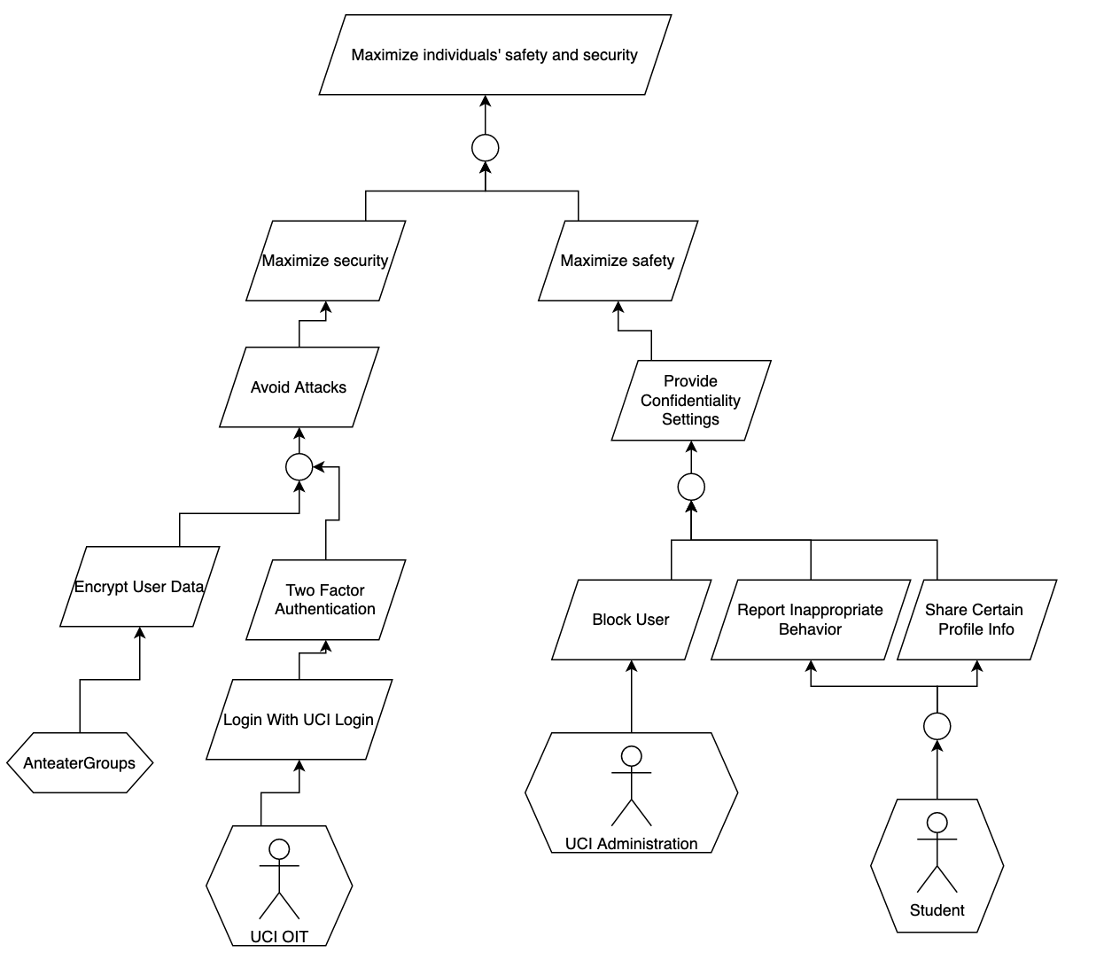

Goal priorities are categorized as Low, Medium, High.

Source numbers refer to the numbered list in the Field Notes section from elicitation sessions.

1. **Maximize individuals’ safety and security**
   1. Definition: Anteater Groups should maximize the safety and security of students while they are using the application.
   2. Type: Soft
   3. Source: 59, 30
   4. Priority: High
2. **Maximize security**
   1. Definition: The system shall maximize security so that student data is protected.
   2. Type: Soft
   3. Source: 59, 30
   4. Priority: High
3. **Avoid Attacks**
   1. Definition: The system should avoid attacks from students and other entities to keep all data secure.
   2. Type: Avoid
   3. Source: 59, 30
   4. Priority: High
4. **Encrypt User Data**
   1. Definition: User data must be encrypted so that sensitive information is protected.
   2. Type: Maintain
   3. Source: 30
   4. Priority: High
5. **Two Factor Authentication**
   1. Definition: The system shall have two factor authentication in order to verify that the user logging in is the actual user.
   2. Type: Maintain
   3. Source: 59
   4. Priority:
6. **Login with UCI Login**
   1. Definition: Users must log in with their UCI Login Credentials in order to use Anteater Groups.
   2. Type: Maintain
   3. Source: 59
   4. Priority: Medium
7. **Maximize safety**
   1. Definition: Anteater Groups must maximize safety so users feel safe and comfortable while using the application.
   2. Type: Soft
   3. Source: 25, 44
   4. Priority: High
8. **Provide Confidentiality Settings**
   1. Definition: There must be confidentiality settings so that users feel comfortable.
   2. Type: Maintain
   3. Source: 25, 44
   4. Priority: High
9. **Block User**
   1. Definition: UCI Administration shall be able to block users from using Anteater Groups if certain users display inappropriate behavior.
   2. Type: Achieve
   3. Source: 25
   4. Priority: High
10. **Report Inappropriate Behavior**
    1. Definition: Students shall be able to report other students that display inappropriate behavior.
    2. Type: Achieve
    3. Source: 25, 52
    4. Priority: High
11. **Share Certain Profile Info**
    1. Definition: Students should be able to share personal information that they want other users to see.
    2. Type: Achieve
    3. Source: 44
    4. Priority: Medium

# Model 4: “Increase administration/wellness center understanding of students’ behaviors”

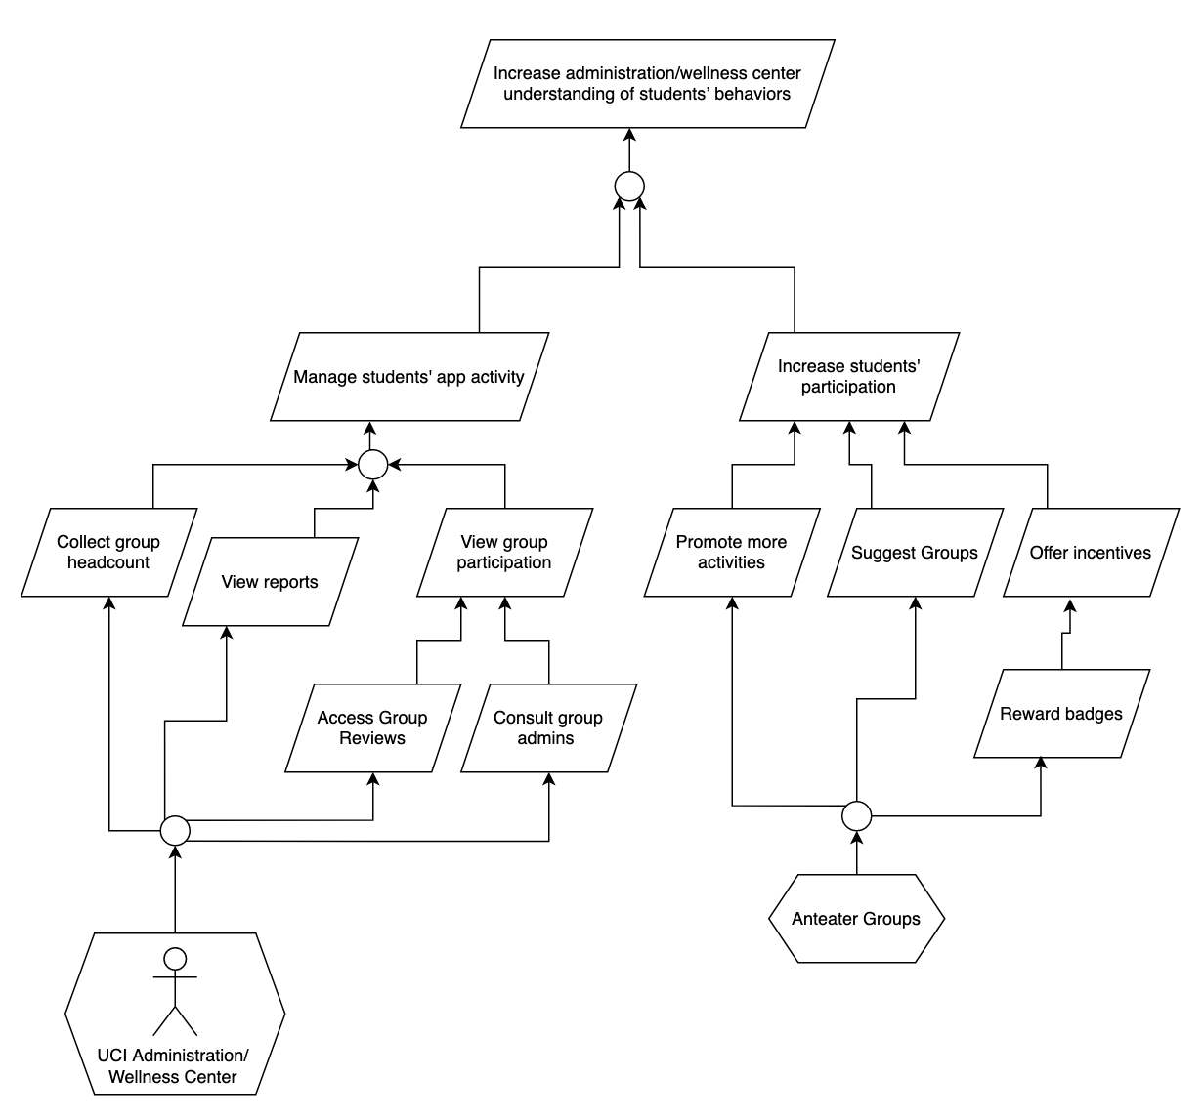

Goal priorities are categorized as Low, Medium, High.

Source numbers refer to the numbered list in the Field Notes section from elicitation sessions.

1. **Increase administration/wellness center understanding of students’ behaviors**
   1. Definition: UCI Administrators and the UCI Wellness Center shall be able to increase their understanding of students’ behaviors.
   2. Type: Soft
   3. Source: Case Study
   4. Priority: High
2. **Manage students’ app activity**
   1. Definition: UCI Administrators and the UCI Wellness Center shall be able to view usage statistics of students on a centralized dashboard.
   2. Type: Achieve
   3. Source: 38, 50
   4. Priority: High
3. **Increase students’ participation**
   1. Definition: Student activity on the app shall be maximized to improve quality of data retrieved on the app.
   2. Type: Soft
   3. Source: 7, 9, 42
   4. Priority: High
4. **Collect Group Headcount**
   1. Definition: UCI Administrators and the UCI Wellness Center shall be able to view the amount of students that have joined in each group.
   2. Type: Achieve
   3. Source: 38, 50
   4. Priority: Medium
5. **View reports**
   1. Definition: UCI Administrators and the UCI Wellness Center shall be able to view reports, along with the previous 4-5 chats where the user flagged as inappropriate in the case of chat reports, in order to address student behavior.
   2. Type: Achieve
   3. Source: 12, 25, 29, 52, 69
   4. Priority: Medium
6. **View group participation**
   1. Definition: UCI Administrators and the UCI Wellness Center shall see values on how many students have created groups and view data on group performance.
   2. Type: Achieve
   3. Source: 38, 50
   4. Priority: High
7. **Promote more activities**
   1. Definition: Admins shall have the authority to promote group activities to prevent unnecessary noise from students promoting activities.
   2. Type: Maintain
   3. Source: 5, 50
   4. Priority: Medium
8. **Suggest groups**
   1. Definition: Students shall be suggested groups based on their interests, mutual friends, and Google Search activity.
   2. Type: Achieve
   3. Source: 2, 67
   4. Priority: Medium
9. **Offer incentives**
   1. Definition: UCI Administrators and the UCI Wellness Center shall offer incentives to students based on their participation in the app.
   2. Type: Achieve
   3. Source: 7, 9, 42
   4. Priority: Medium
10. **Access group reviews**
    1. Definition: UCI Administrators and the UCI Wellness Center shall be able to view the reviews of a group.
    2. Type: Achieve
    3. Source: 71
    4. Priority: Medium
11. **Consult group admins**
    1. Definition: UCI Administrators and the UCI Wellness Center shall be able to consult the admins of each group in order to discuss group performance and get their opinion on how performance within a group can be improved.
    2. Type: Achieve
    3. Source: 50
    4. Priority: Low
12. **Reward badges**
    1. Definition: Virtual badges (gold, silver, bronze) shall be awarded to students based on their attendance with group events. These badges will be public to everyone and displayed on a students’ profile.
    2. Type: Achieve
    3. Source: 9, 42
    4. Priority: Low

# 

# Model 5: “Improve student involvement with campus resources and organizations”

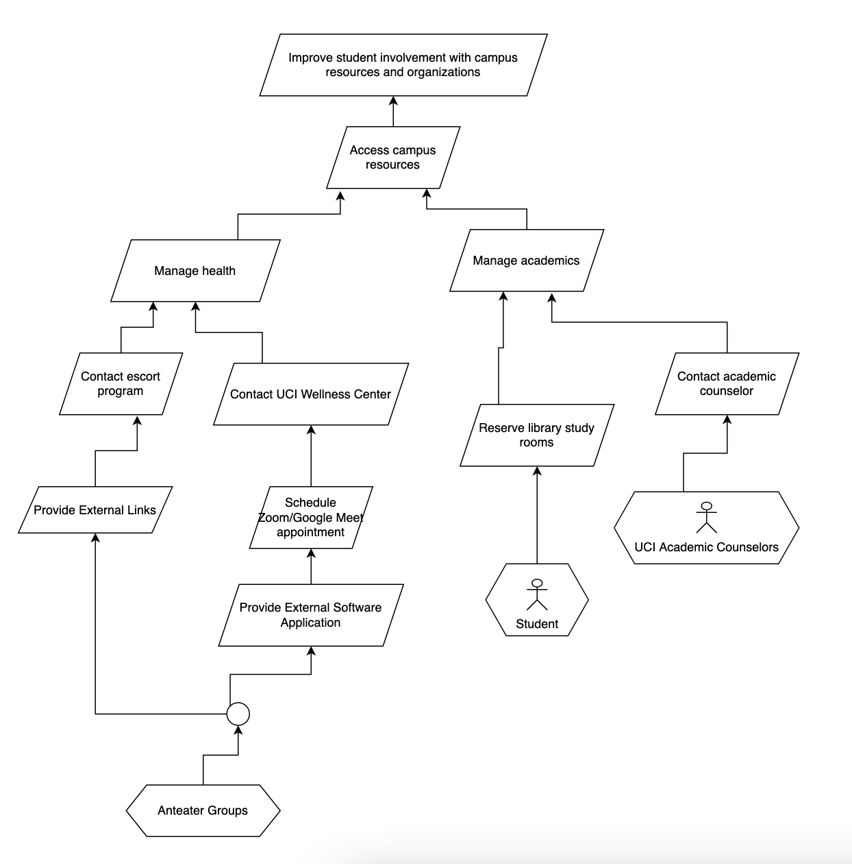

Goal priorities are categorized as Low, Medium, High.

Source numbers refer to the numbered list in the Field Notes section from elicitation sessions.

1. **Improve student involvement with campus resources and organizations**
   1. Definition: Anteater Groups shall improve students’ involvement with campus resources, providing them access to resources within the app and making them aware of campus organizations.
   2. Type: Achieve
   3. Source: Case Study
   4. Priority: High
2. **Access Campus Resources**
   1. Definition: Students shall be able to access or connect to campus resources within the app.
   2. Type: Achieve
   3. Source: 26
   4. Priority: High
3. **Manage Health**
   1. Definition: Students shall be able to use campus resources to improve their mental and physical health.
   2. Type: Achieve
   3. Source: 26
   4. Priority: High
4. **Manage academics**
   1. Definition: Students shall be able to use campus resources to improve their academics.
   2. Type: Achieve
   3. Source: 26
   4. Priority: High
5. **Contact escort program**
   1. Definition: Students shall be able to call the UCI Health Safety escorts through the app when they feel uncomfortable traveling alone.
   2. Type: Achieve
   3. Source: 52
   4. Priority: Medium
6. **Contact UCI Wellness Center**
   1. Definition: Students shall be able to connect to the UCI Wellness center in order to receive mental health help.
   2. Type: Achieve
   3. Source: 26
   4. Priority: Medium
7. **Reserve Library study rooms**
   1. Definition: Students shall be able to reserve study rooms through an integrated system with UCI library.
   2. Type: Achieve
   3. Source: 43
   4. Priority: Medium
8. **Chat with academic counselor**
   1. Definition: Students shall be able to chat with an academic counselor from the app.
   2. Type: Achieve
   3. Source: [Missing Information]
   4. Priority: Medium
9. **Provide External Links**
   1. Definition: Anteater Groups shall provide embedded links to campus resources on the app.
   2. Type: Maintain
   3. Source: 52
   4. Priority: High
10. **Schedule Zoom/ Google Meet appointment**
    1. Definition: Students shall be able to schedule a Zoom or Google Meets appointment with UCI Wellness Center specialists directly through the app.
    2. Type: Achieve
    3. Source: 53
    4. Priority: Low
11. **Provide external software application**
    1. Definition: The system shall support external software applications through third party integrations so that students can connect to campus resources and organization within the application.
    2. Type: Maintain
    3. Source: 52
    4. Priority: High

# Missing Information

Assumptions:

* + In goal model 2, we assumed that students can both earn general participation rewards as well as special awards which are not given to every participating student (e.g. raffles, placing on the leaderboard for competitive events).
  + In goal model 5, we assumed that as students are able to connect to campus resources through the app, such as escorts, library study rooms, mental health specialists, that they may also be able to contact academic counselors as well even though this was not explicitly stated in the elicitation meetings.

Questions:

* + Will students be able to contact academic counselors through Anteater Groups? For example, can they also make appointments through the app, or have a link to the academic counselors’ phone numbers of their respective schools?
  + Will students need to request to be another student’s “friend” on Anteater Groups? In other words, do both students have to approve for them to be friends, and is it one-sided (unfriending them will remove them on both users’ ends or just one user)?

# 

# Team Meeting Minutes

| **Team ID: 3** | | **Date: 5/3/22** |  |  | |
| --- | --- | --- | --- | --- | --- |
| **Team Members (Name)** | | **Role** | | |
| 1. Gail Manlapaz | | Facilitator | | |
| 1. Michael Nguyen | | Participant | | |
| 1. Jaime Park | | Recorder | | |
| 1. Nathan Van | | Participant | | |
|  | |  | | |
|  | |  | | |
| **Agenda for this meeting, List of agenda items** | | **Outcomes** | | |
| 1. Elicitation meeting @ discussion 4/29 | | 10 new questions answered. | | |
| 1. Each member does 1 goal model. | | Each took on a higher level goal. We agreed on 5 goals together and took dibs on which one we’d like to work on individually. We peer reviewed each other’s models. | | |
| 1. Work on a 5th goal model together (everyone). | | We did this goal model first so we all have the same understanding of how we’d like to do our individual models. This goal took the longest to complete because we had trouble wording the subgoals. | | |
| 1. Finalize HW 3, put together pdf. | | Finished HW in several hours. | | |
| ….etc. | |  | | |
| **Problems encountered** | | **Resolution** | | |
| 1. Could not think of how to word the subgoals as goals rather than statements. | Referred to Lecture 5 slides, like the TrainSystem example goal diagram. | | | |
| 1. We had trouble making the top-to-bottom and bottom-to-top organization of goals follow how and why questions. We would have a why goal below it’s how. | We all had to keep asking ourselves “why” and “how” in the context of each goal. This required a lot of rearranging and even removing certain goals as they were not relevant to the higher level goal. | | | |
| 1. We spent hours on this in one day so we frequently had to take mental breaks/ breaks to eat, which elongated the total time we spent on the homework. | We just kept communicating with one another when we had to step out of the Discord call and inform the others when we would return. | | | |
|  |  | | | |
|  | |  | | |
|  | |  | | |
| **Plans for next meeting: Activity** | | **Responsibility** | | |
| 1. Continue elicitation sessions in discussion. | | Everyone. | | |
| 1. Begin next homework if it is released. | | Everyone- should discuss future availability with one another. | | |
|  | |  | | |
|  | |  | | |
|  | |  | | |

# Field Notes

## (Week 2) - 4/12

1. 10-12 fixed groups (no strict number)
2. Ask interest /hobbies/likes upon registration
3. Customization on front page of students interest/hobbies/etc
4. Can you search for groups by some tags or by a group name?
   1. Yes, make it as user friendly as possible
   2. When the student logs in, would be good to search for a group using name or tag
      1. Names and subjects
      2. Should match keyword even if it isn’t exact (near match)
      3. Tags: category (sports), group names: specific (football, baseball etc)
5. Should students be able to promote their own groups/events?
   1. Admin is allowed to promote group or events
   2. Students can be admins of groups they create and promote group activities
   3. Afraid of giving advertisement privilege to each and every student joining in, might be a lot of noise / not a lot of precise advertisements
6. Who are allowed to create groups/events? Who gives admin level account status to students? How to manage duplicate groups/events?
   1. Student leaders need verification with the admin of the app to get permission to create groups/events.
   2. Admin accounts can set groups/events as public (everyone can join) or private (request to join).
7. What are the ways to offer and award incentives to students? Do students get digital goods, physical goods, or reward points to be redeemed through the app or through a third-party partner?
   1. Students can participate in events and get reward points which can then be used to purchase digital goods and digital gifts.
   2. Digital goods and gifts can be sent from student to student.
8. Students who manage roles (ex. ARC: gym, swimming pool) can be onboarded as admins by default
   1. Campus admin would pick a student to be an admin of each group
9. How would rewards be distributed?
   1. Reward based on attendance
      1. Example: yoga meditation, simple reward system, if the student has more than 50% attendance, he/she gets some reward which can be given by the person conducting yoga sessions
   2. Need some system (db) to track attendance
   3. Gold/silver badges based on attendance and will be visible on ‘About Me’ section in profile
10. Multiple groups for the same subject?
    1. Students have the ability to create private groups within bigger group
11. Where can students form groups? On-campus only or any locations off-campus is fine too? Can they form groups at private locations?
    1. Due to the safety and security of the students.
    2. Campus Safety Council, Public Safety, Police Department
12. Who will get reports on users’ interactions and violations?
    1. To allow abusive/inappropriate behavior be reported to the student safety council and the police if necessary. To avoid student bullies and promote professionalism.
13. Organizations and clubs that have already been established - will they be able to create groups so they can recruit students?
    1. Yes (?) board all orgs on the app
14. If we see a class that is taught by 2 diff professors, students might want to have a group specified for each professor
    1. Repeating groups is fine with overlapping classes/different professors (making 2 groups)
    2. People like to shadow groups, doesn’t have to be restrictive, let people mix up/sign up for any groups they want
15. Potential launch date: September 2022
16. Should support at least 10k users (note: 30k students if all students participated)
    1. Should keep in mind scalability
17. Messages in specific channels can be seen by everyone regardless of their group (advertisement channel?)
18. Can send push notifications to everyone for important announcements
    1. Settings: allow user to enable or disable this
19. **Note: no alumni access allowed**
20. Groups centered around classes and sections - do these groups expire at the end of the quarter (to discourage collaboration)?:
    1. We don’t really need to onboard the classes as groups in our app
    2. App is used to promote connectivity, already have canvas for classes, redundant
21. Don’t include academic classes (what you see on webreg or canvas)
    1. Academic clubs are fine
22. How do we gather data on students’ interest to suggest groups?
    1. Competitor app: MeetUp (borrow registration process)
23. Can there be groups for certain majors or schools but not specific courses?
    1. Yes
24. Both android and apple compatible
25. Will the admin check for academic dishonesty or will students have privacy within their groups?
    1. Detect inappropriate/abusive chat with machine learning algorithm, proceed with warning then block student from using application if behavior continues 2 or 3 more times
    2. Students will also have the ability to report other students if there is inappropriate behavior and admin will be able to review report and take action
26. What other features besides creating and promoting connectedness and personal growth should the app have? Do students have the option to seek a mental health hotline or reach a specialist to address their mental health issues through the app?
    1. To further address and enhance social healthiness among the students.
    2. UCI Administration, UCI Student Affairs, UCI Center for Student Wellness & Health Promotion, Software Engineers.
27. Should students see friend suggestions as well as group suggestions? (like if you have a mutual friend w/ someone, will they be suggested to you?)
    1. yes
28. Features to police the app activity for inappropriate behavior
    1. Yes, try to detect inappropriate/abusive behavior using tech first (engineering challenge)
29. When a student reports another student, does the admin come in and view the activity in the chats? Or is there any expectation of privacy, or encryption? Does the administration have full access to all communications?
    1. Don’t give admin full access to chats
    2. Reporting will go to admins along with previous 4-5 chats where the user flagged as inappropriate
30. Should applications support e2e?
    1. Yes, to ensure privacy among students and app data
31. What happens when the lead admin graduates? Will the group be deleted or expired, or will someone take over the admin role?
    1. We don’t want the group to be deleted, would also like to pass on admin access to another student
32. Will the admin role be randomly assigned?
    1. Anything is fine as long as there’s an admin in the group
33. Can we always have a private chat feature?
    1. Yes, once someone in the group is your friend you can privately message them
34. Can students access anteater groups through a website or is the website for admins only?
    1. Just the app for now
35. Where can students form groups? On-campus only or any locations off-campus is fine too? Can they form groups at private locations?
    * 1. Due to the safety and security of the students.
      2. Campus Safety Council, Public Safety, Police Department.

## 

## (Week 3) - 4/15

1. Priorities
   1. Prototype: should have bare minimum of login, can see groups on home screen, can customize it for each student depending on hobbies, functioning chat system,
2. Will students be able to use aliases for their profiles or should they use real names?
   1. Real name
   2. Provide as much flexibility as possible
3. Campus admin can see usage statistics - what other metrics should admin be able to view?
   1. How many students logging in/registering, centralized dashboard of how many students have created groups, single page,
   2. Consistency ?
   3. Data about performance, if groups are/aren’t performing well
      1. Can reach out to group admins to ask them how to make it more engaging
   4. Only public group data ?
4. Can students create groups on their own or do they need to reach out to administrators?
   1. Give them the freedom to make their own groups
   2. Ability to create private groups (can toggle/change at any time - maybe only group admin can change?)
   3. Private groups invisible to public
   4. Students have the option to create public/private groups (can change after creation)
   5. Let’s not have private/public groups but ‘subgroups’ where they are all visible to students but some subgroups have password secure or approval permissions by the admin.**
5. Percentage of up time for application?
   1. Available 24/7
   2. What time should maintenance be performed? (discussion among engineers)
      1. Find time where app is used the least and perform maintenance time during that
6. Will students get notifications or reminders for maintenance?
   1. Once in two months or whenever there is a major break/crit issue
7. What kind of rewards should students receive for participating in group activities/events?
   1. Badges (bronze, silver, gold, etc, titles)
      1. Visible publicly
      2. For other students to see and connect with each other
      3. To get an idea of the student profile
   2. Points
8. How easy is it to integrate the library API?
   1. Libraries as stakeholders
   2. Would require looking at the code
9. What info do students need to complete their profile?
   1. Name
   2. Profile pictures
   3. Short description (optional)
   4. mail id or phone number (optional)
   5. Media upload/ social media links (optional)
10. How to encourage students to explore new interests?
    1. Initial data with their interests from registration on home page, option to see all groups or top 10-15 interests/groups, option to search for groups
11. Tags for age requirements (ex. 21+)
    1. Need to show id
12. Should the app integrate with a third-party map for locating events?
    1. third -party map integration
13. Creating duplicate groups
    * 1. If student creates a subgroup that is similar to existing, ask them if they want to
    1. still create or not
14. Friends list
    1. Close friend sublist
    2. Can create subgroup

## 

## (Week 4) - 4/22

1. Data visualization
   1. Admin will be able to see metrics (app usage, headcount in each group)/data on a single page.
   2. Admin can take measures if the headcount in a group is going down; promote more activities in a group.
2. Timeline
   1. Mock up: 1 month + 1 week
   2. Final product: Targeting release for the next AY Fall 2022 (September 2022).
   3. Have the application ready by orientation so that the department can market or promote app awareness. (MVP)
3. In case of inappropriate behavior, can users contact the police through the app?
   1. Workflow: users report, admins review report, then admin can contact police if needed.
   2. Possible late night concerts: have the features to take the shuttles back home.
   3. Make use of existing UCI services.
   4. Show the phone numbers ^^ on the app
4. Will there be ways to video chat with the mental health specialist?
   1. Students can schedule sessions over Zoom or Google Meet through the app
5. Will there be any accessible options/features for people with disabilities?
   1. Yes, w/ colors and fonts (will require research on what these students need)
6. Dark Mode Feature
7. What would other accounts (professor) be able to view on the application?
   1. Let the view be the same, but have some of the privileges of admins.
   2. Unique features only available to admin accounts
      1. Ex. the right to remove a student from a group
8. Will grad students have different privileges compared to undergrad students?
   1. Let them have the same privileges
9. Are faculty members allowed to join, and if so, can students connect with them like they do with their peers?
   1. no , trying to promote connectivity of students
   2. If they’re trying to train people (ex. Yoga group) they’re allowed to join(onboarded) but can’t use it like an end user
   3. Unlikely be end users
   4. Can be admins
10. Almost everyone associated with UCI has netID so we need to check the database for student status before every login.
11. What is the budget range that will be allocated for this application?
    1. I think he answered this - depends on skills of engineer and other stuff
12. How to reserve locations to meet
    1. library/study centers have their own system so we use that
    2. For non reservable places: let’s not bother because everyone one has access to aldrich park for example
    3. Have a popup reminder or show somewhere on the app that certain locations are under maintenance or are closed

## 

## (Week 5) - 4/29

1. What happens when a group gets too big or has been established for a long time?
   1. “Official Group of UCI”
2. Can anyone create groups or do students have to create subgroups of groups?
   1. Students can have both
   2. Already a group for things like music (100 students registered automatically)
   3. Friends list
   4. You can create a mini group/subgroup
3. Want to have pre-established groups and also groups that students establish when they have the app
4. What if a club/group at school doesn’t want to be onboarded on the app?
   1. Create the Anteater Group, but don’t make them the admin, but if nobody wants to be the admin, don’t create the group at all for them
5. Campus clubs sync with Anteater Groups?
   1. Get permission from the hosts in campus clubs if they want to join Anteater Groups or not before listing them on Anteater Groups.
   2. Can turn group profile off/on
6. Ads on the app?
   1. Group suggestions
   2. Based on close friends
      1. Ex. Your friend is part of this group, would you like to join?
   3. App get data from Google searches?
      1. -make suggestions with keywords
7. Where are notifications stored?
   1. Have a bell icon they can click on, and on that page it’ll show all their notifications
8. What happens if you report a group itself? Or the admins of a group?
   1. The report should go straight to UCI Administration
   2. Report incidents like an event not exist
9. How to make connections or send friend requests over the app?
   1. Browse the name of the person then able to send a friend request
   2. Able to see mutual friends over the person’s profile/friend list
10. Who has access to the reviews of a group?
    1. Rating out of 5 (half-steps allowed, ex. 4.5/5)
    2. Everyone can see them
    3. Separate categories (how active the group is, etc.)
    4. Only members in a group can make reviews
    5. Reviews are both for students/general public and groups
       1. Groups: to gain feedback about how they’re doing
       2. Students: to incentivize them to join the group
11. Are reviews anonymous or are they attached to your name?
    1. Not anonymous, since it could be easy to write things that hurt the group (false accusations)
    2. Reports are anonymous